**Customers Table:-**

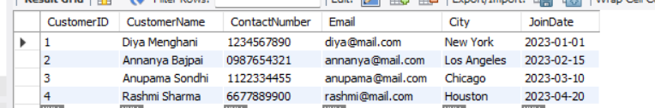

**Orders Table:-**

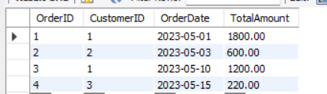

**Products Table:-**

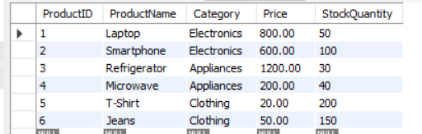

**OrderDetails Table:-**

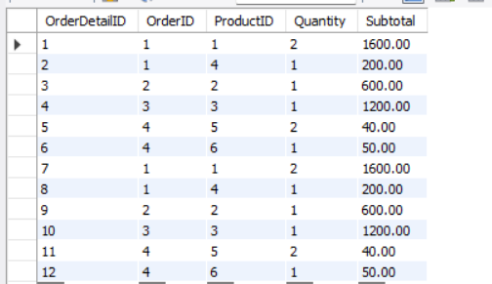

**Inner Join:-**

select Customers.CustomerName, Orders.OrderDate, Orders.TotalAmount

from Customers inner join Orders on Customers.CustomerID = Orders.CustomerID;

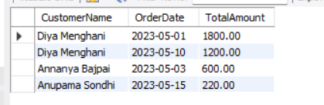

**Left Join:-**

select Customers.CustomerName, Orders.OrderID, Orders.OrderDate, Orders.TotalAmount

from Customers left join Orders on Customers.CustomerID = Orders.CustomerID;

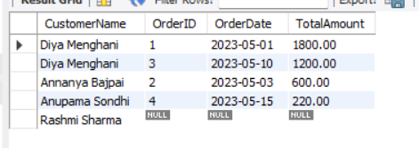

**Right Join:-**

select Customers.CustomerName, Orders.OrderID, Orders.OrderDate, Orders.TotalAmount

from Customers right join Orders on Customers.CustomerID = Orders.CustomerID;

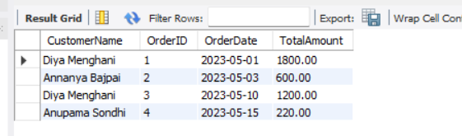

**Full Join:-**

select Customers.CustomerName, Orders.OrderID, Orders.OrderDate, Orders.TotalAmount

from Customers left join Orders on Customers.CustomerID = Orders.CustomerID

union

select Customers.CustomerName, Orders.OrderID, Orders.OrderDate, Orders.TotalAmount

from Customers right join Orders on Customers.CustomerID = Orders.CustomerID;

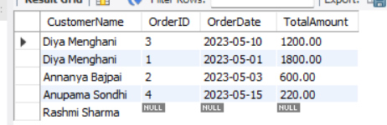

**Joining Multiple Tables:-**

select Orders.OrderID, Customers.CustomerName, Products.ProductName, OrderDetails.Quantity, OrderDetails.Subtotal

from OrderDetails

inner join Orders on OrderDetails.OrderID = Orders.OrderID

inner join Customers on Orders.CustomerID = Customers.CustomerID

inner join Products on OrderDetails.ProductID = Products.ProductID;

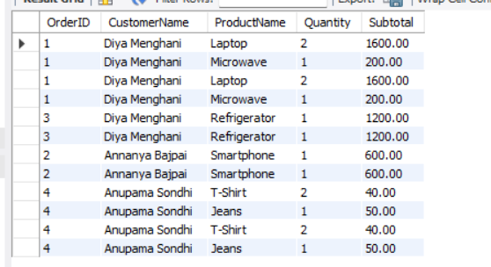

**Listing all products with their associated order quantities**

select Products.ProductName, sum(OrderDetails.Quantity) as TotalOrdered

from Products left join OrderDetails on Products.ProductID = OrderDetails.ProductID

group by Products.ProductName;

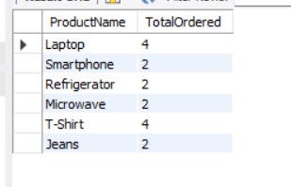

**Finding total revenue generated from each product**

select Products.ProductName, sum(OrderDetails.Subtotal) as TotalRevenue

from Products join OrderDetails on Products.ProductID = OrderDetails.ProductID

group by Products.ProductName order by TotalRevenue desc;

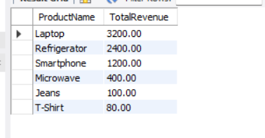

**Listing customers who placed more than one order**

select Customers.CustomerName, count(Orders.OrderID) as NumberOfOrders

from Customers join Orders on Customers.CustomerID = Orders.CustomerID

group by Customers.CustomerName

having count(Orders.OrderID) > 1;

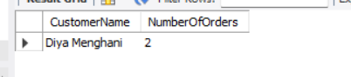

**Listing products that were never ordered**

select ProductName from Products

left join OrderDetails on Products.ProductID = OrderDetails.ProductID

where OrderDetails.ProductID is null;

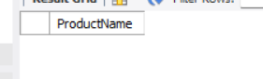

**Listing all orders along with customer and city information**

select Orders.OrderID, Customers.CustomerName, Customers.City, Orders.OrderDate, Orders.TotalAmount from Orders join Customers on Orders.CustomerID = Customers.CustomerID;

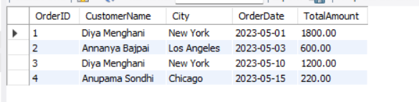

**Showing latest order placed by each customer**

select Customers.CustomerName, max(Orders.OrderDate) as LatestOrderDate

from Customers join Orders on Customers.CustomerID = Orders.CustomerID

group by Customers.CustomerName;

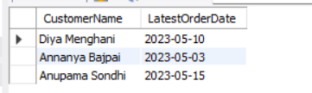

**Listing customers who haven't placed any orders**

select Customers.CustomerName from Customers left join Orders

on Customers.CustomerID = Orders.CustomerID where Orders.OrderID is null;

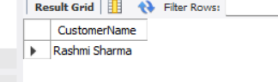

**Finding most ordered product(s)**

select Products.ProductName, sum(OrderDetails.Quantity) as TotalQuantity

from Products join OrderDetails on Products.ProductID = OrderDetails.ProductID

group by Products.ProductName order by TotalQuantity desc limit 1;

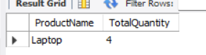

**Getting daily sales with customer count and total amount**

select OrderDate, count(distinct CustomerID) as TotalCustomers, sum(TotalAmount) as TotalSales

from Orders group by OrderDate order by OrderDate;

